**A**

**Project Report**

**On**

**"House-Marketplace"**

**Prepared by**

Naitik Patel (20DCS083)

**Under the guidance of**

Prof. Brijesh Panchal

A Report Submitted to

Charotar University of Science and Technology

For Partial Fulfillment of the Requirements for the

5th Semester Summer Internship-I (CS343)

**Submitted at**



**Department of Computer Science & Engineering**

**Devang Patel Institute of Advance Technology and Research**

**At: Changa, Dist: Anand – 388421**

**July 2022**



**CERTIFICATE**

This is to certify that the report entitled “**House-Marketplace**” is a bonafide work carried out by **Mr. Naitik Patel (20DCS083)** under the guidance and supervision of **Asst. Prof Brijesh Panchal** for the subject **CS343 Summer Internship-I** of 5th Semester of Bachelor of Technology in **Department of Computer Science & Engineering,** **DEPSTAR** at Faculty of Technology & Engineering – CHARUSAT, Gujarat.

To the best of my knowledge and belief, this work embodies the work of candidate himself, has duly been completed, and fulfills the requirement of the ordinance relating to the B.Tech. Degree of the University and is up to the standard in respect of content, presentation and language for being referred to the examiner.

|  |  |
| --- | --- |
| Brijesh Panchal  Assistant Professor  Department of Computer Science & Engineering  DEPSTAR, CHARUSAT, Changa, Gujarat. | Mr. Kandarp Rajyaguru  Team Leader  Web Brains Technologies  Vadodara |
| Prof. Parth Goel  Head of Department  Department of Computer Science & Engineering  DEPSTAR, CHARUSAT, Changa, Gujarat | Dr. Amit Ganatra  Principal, DEPSTAR  Dean, FTE  CHARUSAT, Changa, Gujarat. |

**Devang Patel Institute of Advance Technology And Research At: Changa, Ta. Petlad, Dist. Anand, PIN: 388 421. Gujarat**



**CERTIFICATE**

This is to certify that the report entitled “**House-Marketplace**” is a bonafide work carried out by **Mr. Naitik V Patel (20DCS083)** under the guidance and supervision of **Asst. Prof Brijesh Panchal** for the subject **CS343 Summer Internship-I** of 5th Semester of Bachelor of Technology in **Department of Computer Science & Engineering,** **DEPSTAR** at Faculty of Technology & Engineering – CHARUSAT, Gujarat.

To the best of my knowledge and belief, this work embodies the work of candidate himself, has duly been completed, and fulfills the requirement of the ordinance relating to the B.Tech. Degree of the University and is up to the standard in respect of content, presentation and language for being referred to the examiner.

|  |  |
| --- | --- |
| Brijesh Panchal  Assistant Professor  Department of Computer Science & Engineering  DEPSTAR, CHARUSAT, Changa, Gujarat. |  |
| Prof. Parth Goel  Head of Department  Department of Computer Science & Engineering  DEPSTAR, CHARUSAT, Changa, Gujarat | Dr. Amit Ganatra  Principal, DEPSTAR  Dean, FTE  CHARUSAT, Changa, Gujarat. |

**Devang Patel Institute of Advance Technology And Research At: Changa, Ta. Petlad, Dist. Anand, PIN: 388 421. Gujarat**

**Internship Completion Certificate**

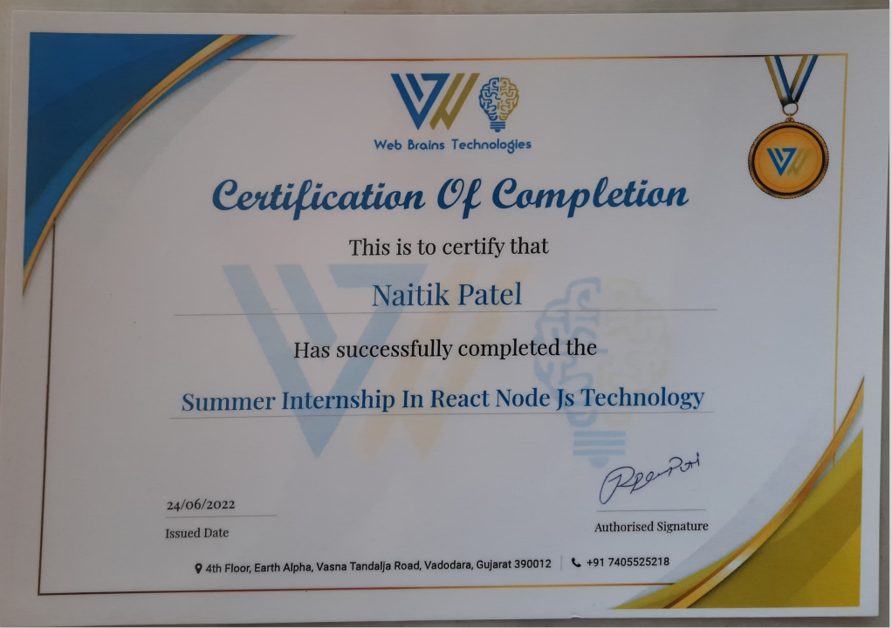

**DECLARATION OF ORIGINALITY**

I hereby declare that the project report entitled “House-Marketplace” submitted by me to Devang Patel Institute of Advance Technology and Research, Changa in partial fulfillment of the requirement for the award of the degree of B.Tech in Computer Science & Engineering, DEPSTAR/FTE is a record of bonafide e CS343 Summer Internship-I (project work) carried out by me under the guidance Asst. Prof Brijesh Panchal. I further declare that the work carried out and documented in this project report has not been submitted anywhere else either in part or in full and it is the original work, for the award of any other degree or diploma in this institute or any other institute or university.

Naitik Patel (20DCS083)

Brijesh Panchal

Assistant Professor

DEPSTAR,CHARUSAT-CHANGA

**ACKNOWLEDGEMENT**

We would like to express our special thanks of gratitude to our guide

**Asst. Prof. Brijesh Panchal** allowed me to do this wonderful project on the topic ‘**House-Marketplace**’, and made themselves available for all the queries, questions, and suggestions from their busy schedule.

Secondly for the success of my project, I would like to acknowledge the world of the Internet is YouTube, W3 schools and , websites which it very easy for me to learn web development.

Thank you,

NAITIK PATEL

(20DCS083)

**ABSTRACT**

Everyone has experienced in their life at least one time that when they want to purchase or sell a house also for rent they took a broker for that but broker charges a 1-2 % amount from that which is too expensive for us. So I have decided to make a website on which users can post their house for rent or sell or also can purchase or take for rent without paying any amount. Users can sign in and explore all houses as well as contact the landlord if interested in the deal. I have hosted a website on vercel which you can check out here <https://house-market-place-ecru.vercel.app/>

**TABLE OF CONTENTS**

Certificates

Offer letter

Abstract

Acknowledgment

Table of contents

List of figures

**Chapter 1 Project Definition 1**

* 1. Project Overview 2
  2. Objective 3
  3. Scope 3
  4. Tools and Technologies 4

**Chapter 2 Description 11**

* 1. Project Planning 11

2.1.1 Gantt Chart 12

**Chapter 3 Major Functionality 13**

3.1 Functionalities 13

**Chapter 4 System Flow Chart 16**

4.1 Flow chart 16

**Chapter 5 Screenshots of Project Output 19**

Implementation Environment 20

* 1. Coding Standards 21

5.3 Example 22

**Chapter 6 Limitations of The Project 25**

**Chapter 7 Project Outcomes 27**

7.1 Summary of project work and outcomes 28

**Chapter 8 Future Enhancements 29**

**Chapter 9 Reference 31**

**LIST OF FIGURES**

4.1 Flow Chart 17

5.1. Login & Signup Page 19

5.2. Home Page 19

5.3. Rent Page 20

5.4. House Detail Page 20

5.5. Profile page 21

5.6. Contact Page 21

5.7. Create Listing Page 22

CHAPTER 1

PROJECT DEFINITION

* 1. **Project Overview:**

A Responsive Web Application on which users can sell, purchase And also give their house for rent and take as well.

* 1. **Objective :**

My objective is to make a platform only for the people who want to sell or purchase the properties. It is a user-friendly platform so that everyone can post their house and also refer other houses so that they can purchase.

* 1. **Scope :**

As mentioned above it is user-friendly so that is helpful to the people they can have one-one conversations and create a deal without paying any amount to a third-party broker.

CHAPTER 2

DESCRIPTION

**Project Planning :**

* User will Sign in / Sign up first.
* Then select categories according to their requirements. (Sell/Rent)
* Users can go to create a listing page to sell/rent their own house.
* Also users can put the offers.
* Interested can contact Landlord directly using a message box.
* After the deal user can delete or update the post.
* I will host this on vercel.com.

CHAPTER 3

SOFTWARE AND HARDWARE REQUIREMENTS

* **Software Requirements**
* Browser for Ex. Chrome, Brave, FireFox, etc.
* **Hardware Requirements**
* Laptop, Computer, Phone
* 2 GB RAM
* **Tools and Technologies :**
* HTML-CSS

HTML is used for structure and CSS is used for styling.

* JavaScript

JavaScript is the logic of every program.

* React JS

ReactJS is a library of JavaScript. React makes it painless to create interactive UIs.

* Firebase

Firebase is the simplest backend it contains many functionalities like Authentication, database, Hosting, etc.

* Bootstrap & Material UI

It is a CSS Library used to build beautiful UI.

* ES Lint

ES Lint is used to find an error and fixing in the Code editor.

* Prettier

It is used for the formatting of code.

* Git/GitHub

GitHub is open-source on which everyone can post their development skills.

* Framer-Motion

It is used to add Animation to Components like cards, images, etc.

* Vercel

Vercel is used for hosting the website.

CHAPTER 4

MAJOR FUNCTIONALITY

* 1. **Functionalities:**

A Responsive Web Application on which users can sell, purchase And also give their house for rent and take as well.

* User can put max 10 images.
* Attractive UI with animation.
* Contact Landlord section.
* Post house for Rent and Sell.
* Authentication with Google Or Email Password.
* User’s Profile section.
* Users can update and delete their house after completed theirs.
* Different sections for a special offer on selling and rent houses.
* User can recover Forgot password.

CHAPTER 5

FLOW CHART

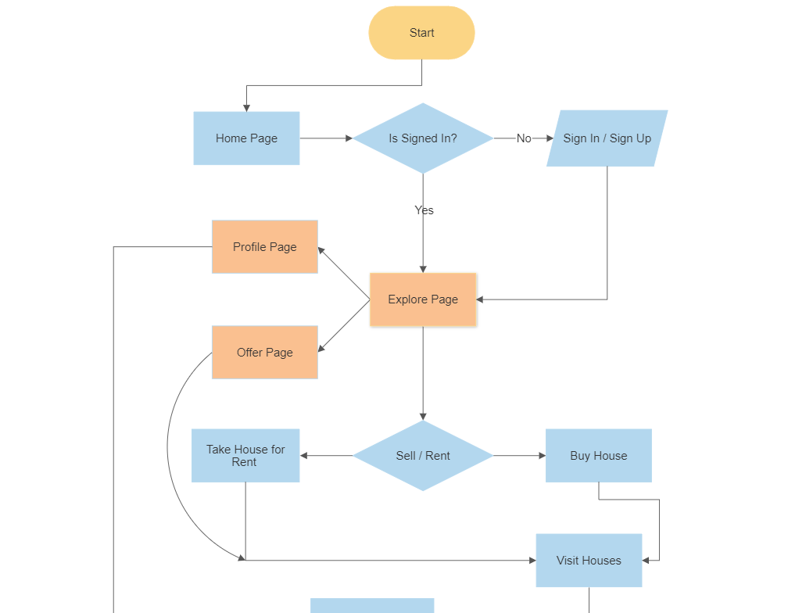

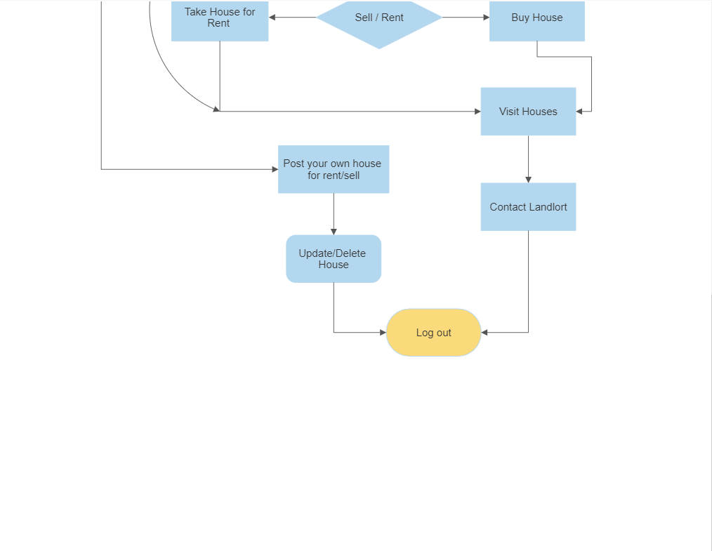

Fig 4.1 Flow chart

CHAPTER 6

SCREENSHOT OF PROJECT

This is the first page of my project. Users will signin before moving to the main page or users can Signup first and then move further.

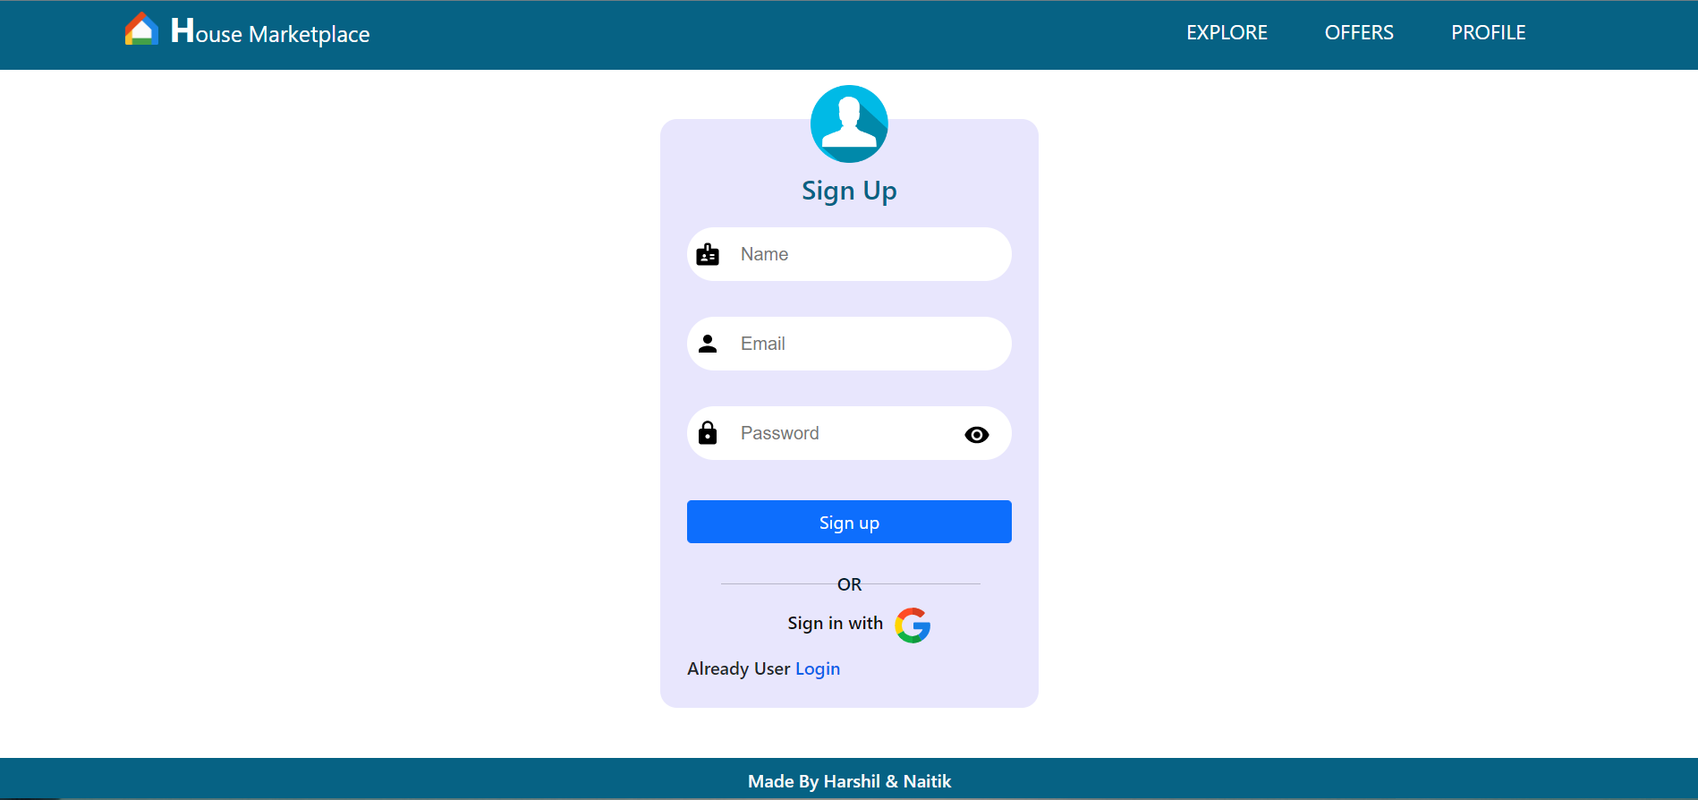

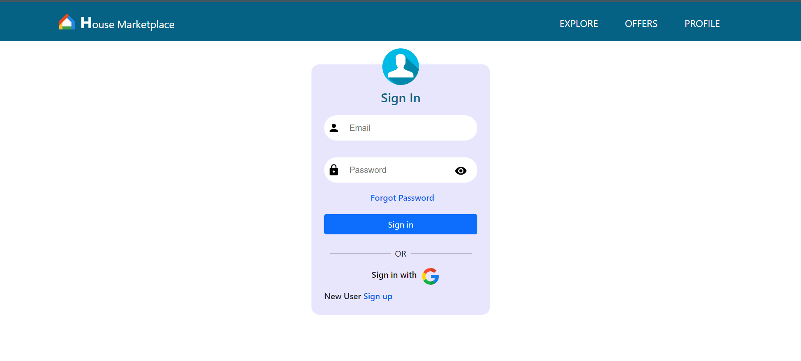

Fig 5.1 Login & Signup Page

This is the Home page here first you can see the slider which shows newest posted 5 houses for sell or rent by clicking on them you can visit see more details. Also in category user can select by their requirenment.

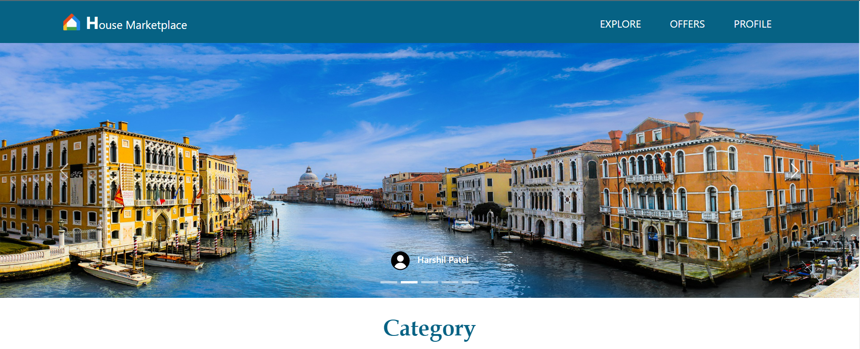 

Fig 5.2 Home Page

Here user can see the houses for rent, by clicking on load more button more houses will be load from database.



Fig 5.3 Rent Page



Fig 5.4 House Detail Page

Here User can see Profile Details and Houses that listed by user.

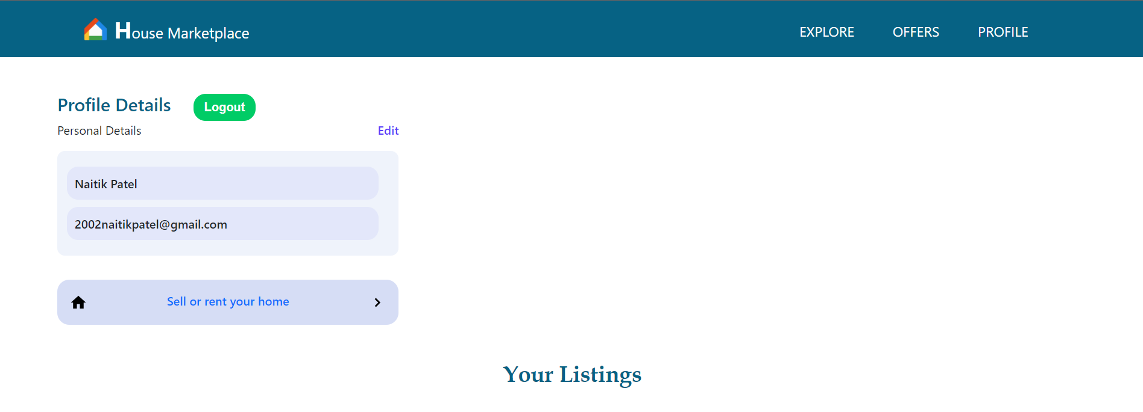

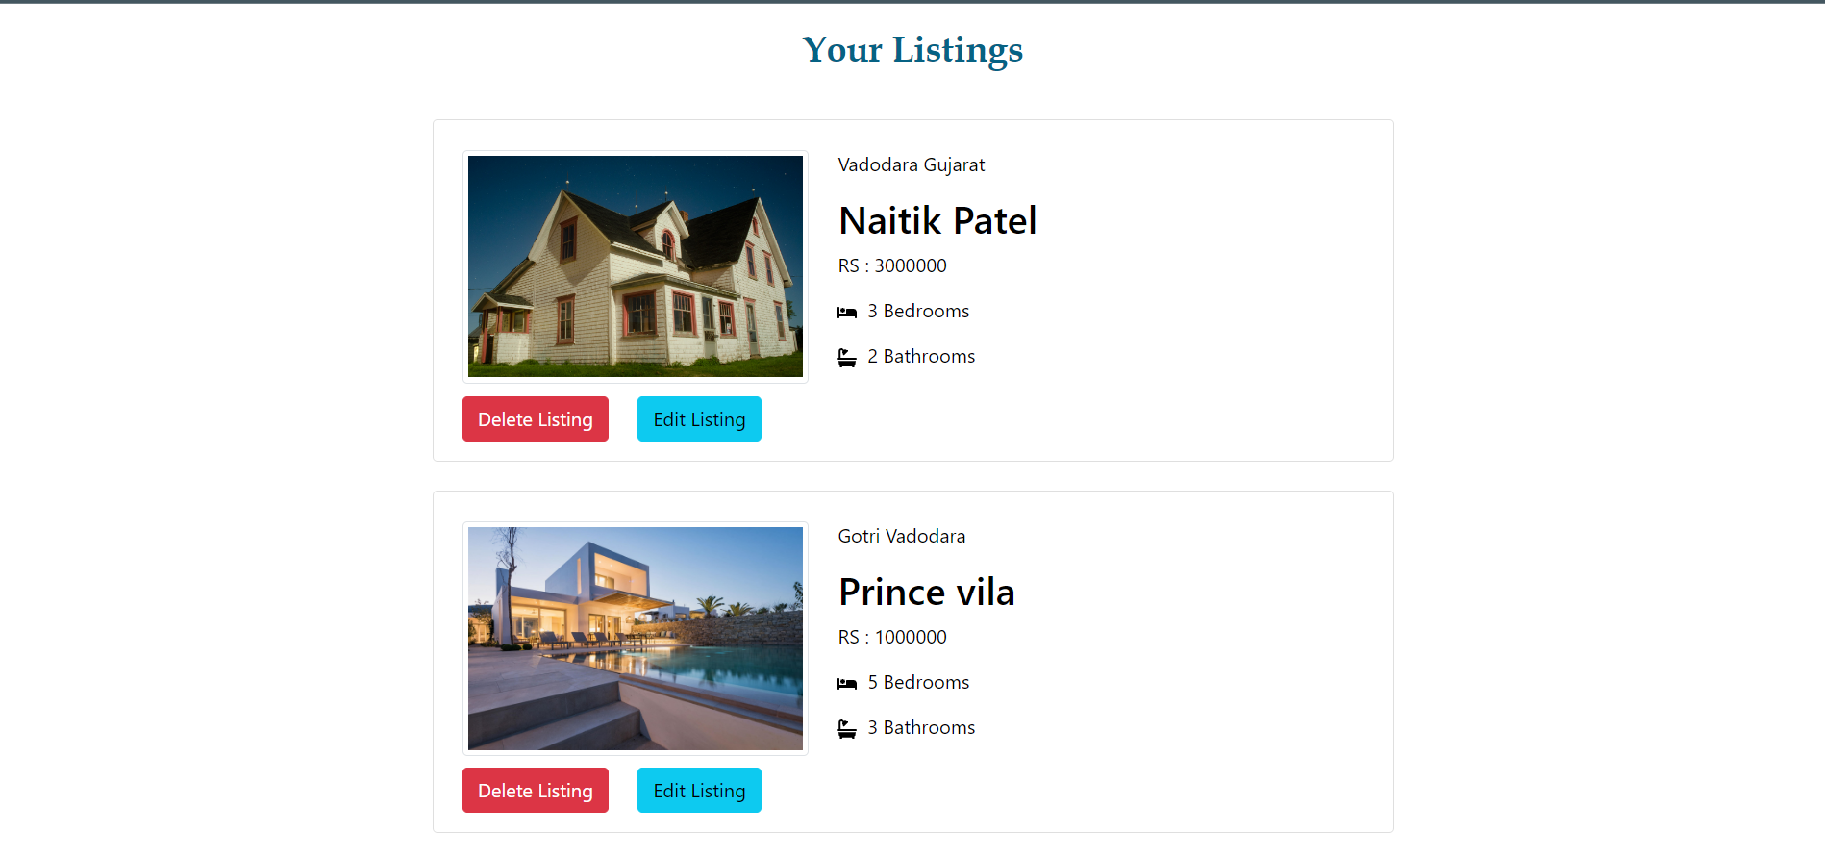

Fig 5.5 Profile Page

Interested can contact to the Landlord via sending message here.

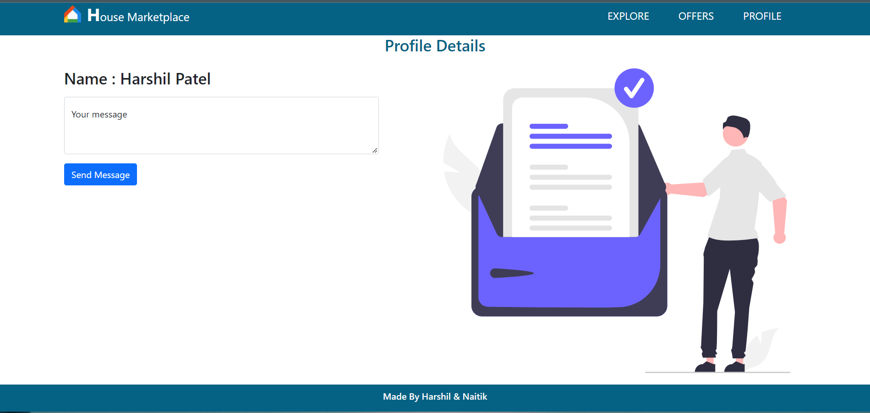

Fig 5.6 Contact Page

User can create listing here. User can select upto 6 images to post. Also they can update this details.

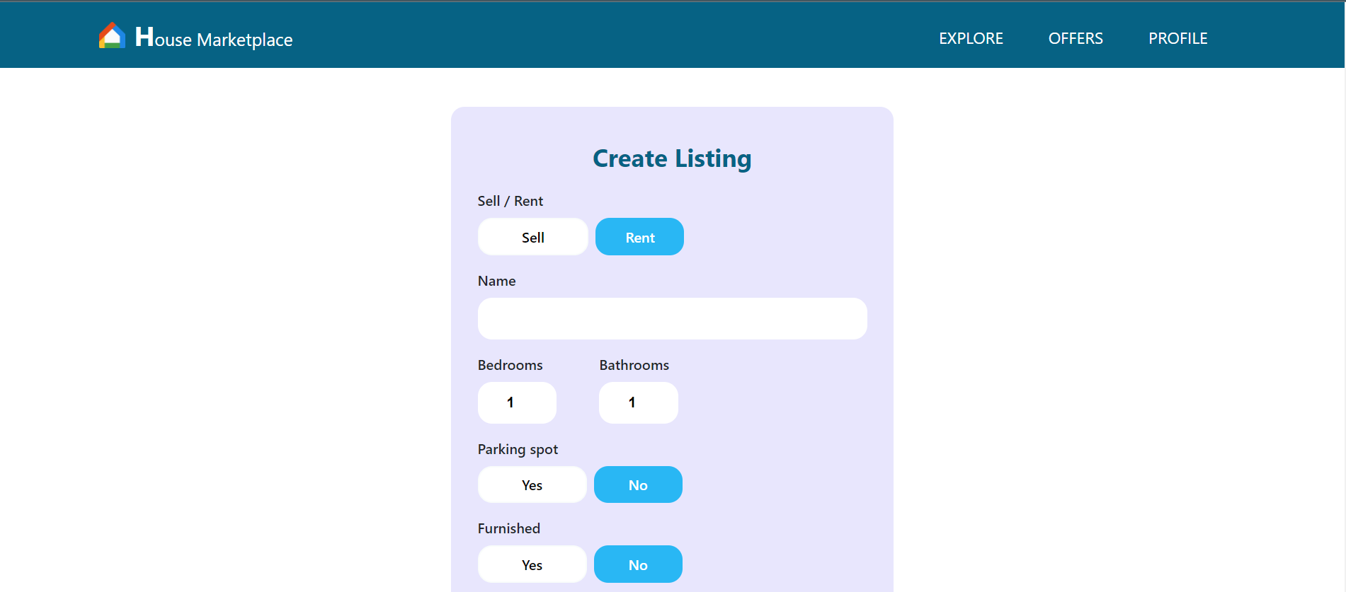

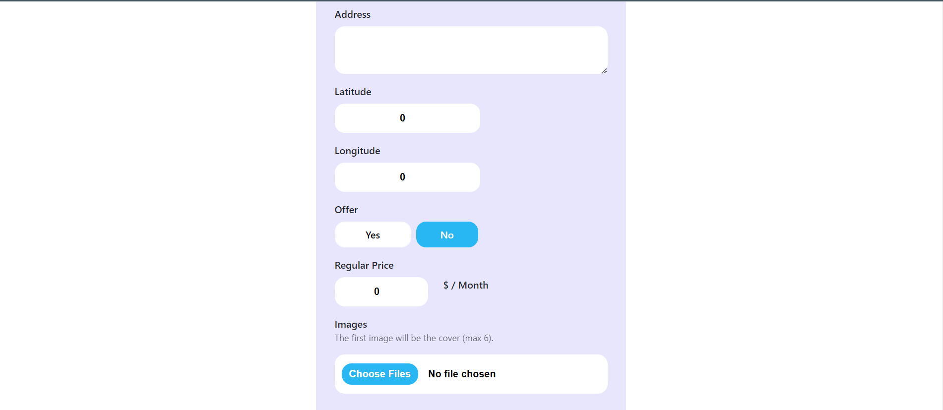



Fig 5.7 Create Listing Page

CHAPTER 7

LIMITATIONS OF PROJECT

**Limitations/ Improvements we could make:**

* Some high quality images may not upload.
* In Offer page sell and rent both type of houses are mixed.
* User can not sort houses by their area.

CHAPTER 8

PROJECT OUTCOMES

**Project Outcomes:**

I introduced to the world of web development, I stared with fundamentals like HTML, CSS and JavaScript. Then I build up to ReactJs and it’s libraries. I learned GitHub and posted my project on it. Also I used Firebase in my project so I got knowledge how to fetch & Uplaod data from a Database and Used Authentication. In the end, I learned how to use framer-motion(Animation) in Project, Also I hosted my website on Vercel which you can check out from this link <https://house-market-place-ecru.vercel.app/>

CHAPTER 9

FUTURE ENHANCEMENTS

**Future Enhancements:**

* Try to Add Sorting functionality.
* Will add Google map location for individual house.
* Try to add a advertise for financial purpose.

CHAPTER 10

REFERENCES

**References:**

* <https://vercel.com/>
* <https://docs.github.com/en/get-started/using-git/about-git>
* <https://prettier.io/docs/en/index.html>
* <https://eslint.org/docs/user-guide/getting-started>
* <https://reactjs.org/tutorial/tutorial.html>
* <https://www.learn-js.org/>
* <https://www.w3schools.com/html/>
* <https://www.cs.utexas.edu/~learnlogic/truthtables/>
* <https://web.stanford.edu/class/cs103/tools/truth-table-tool/>